**All Table code :**

-- Create Employees table

CREATE TABLE Employees (

EmployeeID INT PRIMARY KEY,

FirstName VARCHAR(255),

LastName VARCHAR(255),

Branch NCHAR(5),

Age NUMERIC(2, 0),

NIC NCHAR(15),

Scale NUMERIC(1, 0),

Salary INT,

JoiningDate DATE,

OvertimeHours FLOAT,

JobTitle VARCHAR(255),

DepartmentId INT

);

-- Insert data for the Employees table

INSERT INTO Employees (EmployeeID, FirstName, LastName, Branch, Age, NIC, Scale, Salary, JoiningDate, OvertimeHours, JobTitle, DepartmentId)

VALUES (1, 'Noman', 'Ijaz', 'NY', 30, '123456789012345', 1, 65000, TO_DATE('2022-05-10', 'YYYY-MM-DD'), 5.5, 'Manager', 1);

INSERT INTO Employees (EmployeeID, FirstName, LastName, Branch, Age, NIC, Scale, Salary, JoiningDate, OvertimeHours, JobTitle, DepartmentId)

VALUES (2, 'Ali', 'ahmad', 'NY', 30, '123456789012345', 1, 75000, TO_DATE('2022-05-10', 'YYYY-MM-DD'), 5.5, 'Manager', 1);

INSERT INTO Employees (EmployeeID, FirstName, LastName, Branch, Age, NIC, Scale, Salary, JoiningDate, OvertimeHours, JobTitle, DepartmentId)

VALUES (3, 'Hamza', 'khan', 'NY', 30, '123456789012345', 1, 85000, TO_DATE('2022-05-10', 'YYYY-MM-DD'), 5.5, 'Manager', 1);

INSERT INTO Employees (EmployeeID, FirstName, LastName, Branch, Age, NIC, Scale, Salary, JoiningDate, OvertimeHours, JobTitle, DepartmentId)

VALUES (4, 'Bial', 'khan', 'NY', 30, '123456789012345', 1, 95000, TO_DATE('2022-05-10', 'YYYY-MM-DD'), 5.5, 'Manager', 1);

INSERT INTO Employees (EmployeeID, FirstName, LastName, Branch, Age, NIC, Scale, Salary, JoiningDate, OvertimeHours, JobTitle, DepartmentId)

VALUES (5, 'Faraz', 'maqsood', 'NY', 30, '123456789012345', 1, 175000, TO_DATE('2022-05-10', 'YYYY-MM-DD'), 5.5, 'Manager', 1);

INSERT INTO Employees (EmployeeID, FirstName, LastName, Branch, Age, NIC, Scale, Salary, JoiningDate, OvertimeHours, JobTitle, DepartmentId)

VALUES (6, 'sameer', 'khan', 'NY', 30, '123456789012345', 1, 5000, TO_DATE('2022-05-10', 'YYYY-MM-DD'), 5.5, 'Manager', 1);

INSERT INTO Employees (EmployeeID, FirstName, LastName, Branch, Age, NIC, Scale, Salary, JoiningDate, OvertimeHours, JobTitle, DepartmentId)

VALUES (7, 'Hammad', 'Ijaz', 'NY', 30, '123456789012345', 1, 705000, TO_DATE('2022-05-10', 'YYYY-MM-DD'), 5.5, 'Manager', 1);

INSERT INTO Employees (EmployeeID, FirstName, LastName, Branch, Age, NIC, Scale, Salary, JoiningDate, OvertimeHours, JobTitle, DepartmentId)

VALUES (8, 'usman', 'khan', 'NY', 30, '123456789012345', 1, 750000, TO_DATE('2022-05-10', 'YYYY-MM-DD'), 5.5, 'Manager', 1);

INSERT INTO Employees (EmployeeID, FirstName, LastName, Branch, Age, NIC, Scale, Salary, JoiningDate, OvertimeHours, JobTitle, DepartmentId)

VALUES (9, 'khurram', 'Riaz', 'NY', 30, '123456789012345', 1, 75000, TO_DATE('2022-05-10', 'YYYY-MM-DD'), 5.5, 'Manager', 1);

INSERT INTO Employees (EmployeeID, FirstName, LastName, Branch, Age, NIC, Scale, Salary, JoiningDate, OvertimeHours, JobTitle, DepartmentId)

VALUES (10, 'raheel', 'shareef', 'NY', 30, '123456789012345', 1, 55000, TO_DATE('2022-05-10', 'YYYY-MM-DD'), 5.5, 'Manager', 1);

CREATE TABLE Department (

DepartmentID NUMBER PRIMARY KEY,

DepartmentName VARCHAR2(50)

);

-- Sample data for Departments table

INSERT INTO Department (DepartmentID, DepartmentName)

VALUES (1, 'HR');

INSERT INTO Department (DepartmentID, DepartmentName)

VALUES (2, 'Sales');

INSERT INTO Department (DepartmentID, DepartmentName)

VALUES (3, 'Finance');

-- Order table

CREATE TABLE Orders (

Order_ID Int PRIMARY KEY,

Customer_ID Int,

Order_Date Date

);

-- Sample data for Orders table

INSERT INTO Orders (Order_ID, Customer_ID, Order_Date)

VALUES

(101, 1, '2023-01-15'),

(102, 2, '2023-02-20'),

(103, 3, '2023-03-25'),

-- Add more orders as needed

;

CREATE TABLE Products (

Product_ID Int PRIMARY KEY,

Product_Name VARCHAR(50),

Unit_Price float

);

-- Sample data for Products table

INSERT INTO Products (Product_ID, Product_Name, Unit_Price)

VALUES (201, 'Product A', 10.99);

INSERT INTO Products (Product_ID, Product_Name, Unit_Price)

VALUES (202, 'Product B', 12.99);

INSERT INTO Products (Product_ID, Product_Name, Unit_Price)

VALUES (203, 'Product C', 13.99);

INSERT INTO Products (Product_ID, Product_Name, Unit_Price)

VALUES (204, 'Product D', 14.99);

CREATE TABLE Customers (

Customer_ID Int PRIMARY KEY,

Customer_Name VARCHAR(55),

Sales_Representative_ID Int

);

-- Sample data for Customers table

INSERT INTO Customers (Customer_ID, Customer_Name, Sales_Representative_ID)

VALUES

(1, 'Customer X', 1),

(2, 'Customer Y', 2),

(3, 'Customer Z', 1),

;

CREATE TABLE OrderDetails (

Order_ID Int,

Product_ID Int,

Quantity Int

);

-- Sample data for OrderDetails table

INSERT INTO OrderDetails (Order_ID, Product_ID, Quantity)

VALUES (101, 201, 5);

INSERT INTO OrderDetails (Order_ID, Product_ID, Quantity)

VALUES (102, 202, 15);

INSERT INTO OrderDetails (Order_ID, Product_ID, Quantity)

VALUES (103, 203, 25);

Task #1:

SELECT EmployeeID, FirstName, LastName

FROM Employees

WHERE Salary > 70000

ORDER BY Salary DESC;

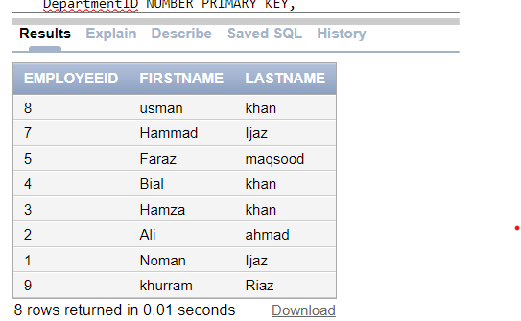

Task #2:

SELECT first_name || ' ' || last_name AS full_name

FROM Employees;

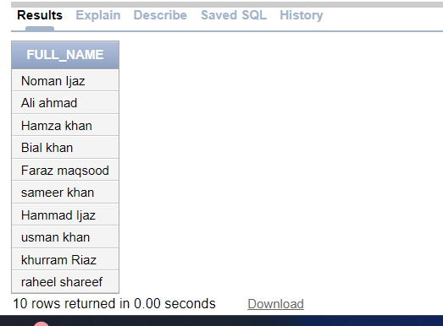

Task #3:

SELECT DISTINCT Product_Name

FROM Products;

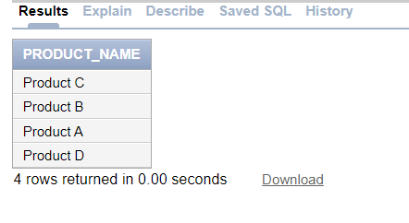

Task #4:

SELECT Order_Id, Customer_Id, Order_Date

FROM Orders

WHERE Order_date > TO_DATE('2023-01-01', 'YYYY-MM-DD');

Task #5:

SELECT *

FROM Customers

WHERE City = 'New York' OR City = 'Los Angeles';

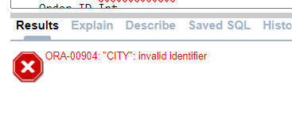

**Reason :**Because “City ” is not part of Customers table.Customers have no attribute of “City”

Task #6:

SELECT

P.Product_Name,

SUM(OD.Quantity) AS Total_Units_Sold,

SUM(OD.Quantity * P.Unit_Price) AS Total_Revenue

FROM

Products P

JOIN

OrderDetails OD ON P.Product_ID = OD.Product_ID

JOIN

Orders O ON OD.Order_ID = O.Order_ID

WHERE

TO_CHAR(O.Order_Date, 'YYYY') = '2023'

GROUP BY

P.Product_Name

ORDER BY

Total_Revenue DESC;

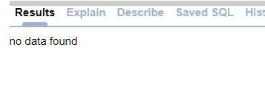

Task #7:

SELECT

D.DepartmentName,

COUNT(E.EmployeeID) AS TotalEmployees,

AVG(E.Salary) AS AverageSalary

FROM

Department D

JOIN

Employees E ON D.DepartmentID = E.DepartmentID

GROUP BY

D.DepartmentName

HAVING

AVG(E.Salary) > 60000;

+

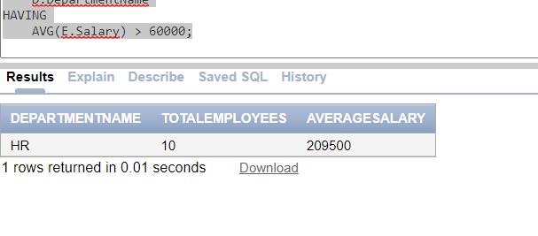

Task #8:

SELECT

C.Customer_Name,

COUNT(O.Order_ID) AS TotalOrders

FROM

Customers C

JOIN

Orders O ON C.Customer_ID = O.Customer_ID

GROUP BY

C.Customer_Name

HAVING

COUNT(O.Order_ID) > 3;

Output:

Task #9:

SELECT

EmployeeID,

FirstName,

LastName,

CASE

WHEN Salary < 50000 THEN Salary * 0.10

ELSE 0

END AS Bonus

FROM

Employees;

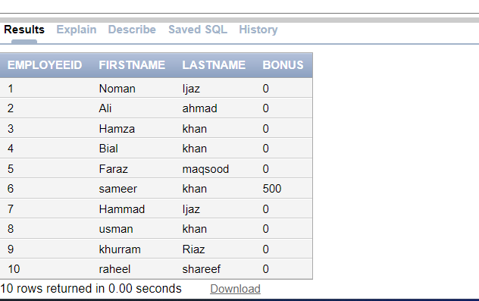

Task #10:

SELECT *

FROM Employees

ORDER BY (Salary + (CASE WHEN Salary < 50000 THEN Salary * 0.10 ELSE 0 END)) DESC

FETCH FIRST 5 ROWS ONLY;

# Task #11:

SELECT *

FROM (

SELECT

EmployeeID,

FirstName,

LastName,

(Salary + (CASE WHEN Salary < 50000 THEN Salary * 0.10 ELSE 0 END)) AS CombinedEarnings

FROM

Employees

ORDER BY

CombinedEarnings DESC

)

WHERE ROWNUM <= 5;

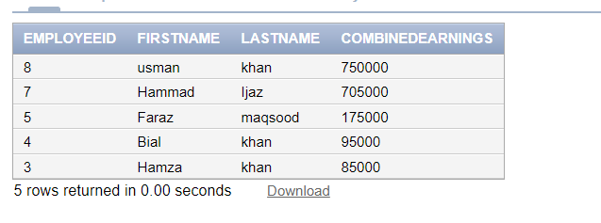

# Task #12:

SELECT

product_id,

SUM(Quantity) AS TotalQuantitySold

FROM

OrderDetails

GROUP BY

Product_Id

HAVING

SUM(Quantity) > 50;

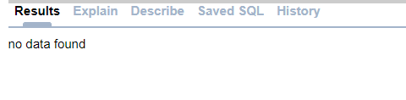

# Task #13:

SELECT

C.Customer_Name,

SUM(O.order_amount) AS TotalOrderAmount

FROM

Customers C

JOIN

Orders O ON C.Customer_Id = O.Customer_Id

WHERE

TO_CHAR(O.Order_Date, 'YYYY') = '2023'

GROUP BY

C.Customer_Name

ORDER BY

TotalOrderAmount DESC

FETCH FIRST 1 ROW ONLY;

# Task #14

SELECT location, AVG(order_count) AS avg_orders

FROM (

SELECT c.location, COUNT(o.order_id) AS order_count

FROM Customers c

LEFT JOIN Orders o ON c.customer_id = o.customer_id

GROUP BY c.location

)

GROUP BY location;

# Task #15

SELECT employee_id, first_name, last_name, hire_date

FROM employees

WHERE EXTRACT(YEAR FROM hire_date) = 2022

ORDER BY hire_date ASC;

# Task #16

SELECT product_name, unit_price

FROM Products

WHERE unit_price < (SELECT AVG(unit_price) FROM Products);

# Task #17

SELECT *

FROM Customers

WHERE customer_id IN (SELECT DISTINCT customer_id FROM Orders WHERE EXTRACT(YEAR FROM order_date) = 2023)

ORDER BY customer_name;

# Task #18

SELECT o.order_id, o.customer_id, o.order_date

FROM Orders o

JOIN Customers c ON o.customer_id = c.customer_id

WHERE c.sales_rep_id IN (SELECT employee_id FROM employees WHERE department_id = (SELECT department_id FROM departments WHERE department_name = 'Marketing'))

ORDER BY o.order_date ASC;

# task #19

SELECT e.employee_id, e.first_name, e.last_name, COUNT(o.order_id) AS total_orders_placed

FROM employees e

LEFT JOIN Orders o ON e.employee_id = o.sales_rep_id

GROUP BY e.employee_id, e.first_name, e.last_name

HAVING COUNT(o.order_id) >= 10;

# task #20

OrderDetails tables to compute this, and display the category name along with the total revenue.

SELECT p.Category, SUM(od.quantity * p.unit_price) AS total_revenue

FROM Products p

JOIN OrderDetails od ON p.ProductId = od.ProductId

GROUP BY p.Category